EWSD
SUBSCRIBER & TARIFF ADMINISTRATION

1.0 Subscriber Administration
1.1 Directory Number Administration
2.1 Analog Subscriber Administration
2.2 Subscriber Controlled Facilities
2.3 Other Subscriber Features
2.4 Miscellaneous Facilities
2.5 Meter Observation Administration
2.6 Analog PBX Administration

3.0 Tariff Administration
3.1 Example for Creation of Zone Points

1.0 SUBSCRIBER ADMINISTRATION
1.1 Directory number administration
1.1.1 Area Code
For creating the area code following command will be used.
ENTR AREA CODE: LAC = XXX, DLU = X;
One area code can be grouped with maximum 32 DLUs with one command. If there are more DLUs to be grouped with the command, has to be given again. Other commands related to area codes are :
DISP AREACODE
MOD AREACODE
CAN AREACODE
1.1.2 Display Directory no. blocks
For displaying the directory number blocks following command will be used
DISP DN: LAC = X, DN = X;
This command will give the list of all directory number block existing in the exchange (both active and not active DN blocks).
1.1.3 Creation of Directory no. blocks :
Directory number blocks can be created with the help of following command
CR DN: LAC = 0575, DN = 540100&&540109;
This command will create a block of 10 directory numbers, with starting DN as 540100 and the ending DN as 540109.
Still these directory numbers cannot be allotted to subscribers, because they have not still become active. This can be confirmed by giving the command
DISP DN: LAC = X, DN = X;
The command will give the listing of all active and not active directory number blocks.
For activating the directory number block, they have to be associated with code points. This can be achieved with the following command
CR CPT: CODE=54010, TRATYP = CPTDN, LAC = 0575;
In the above mentioned command, the code value will be the common digit combination value of the directory number block (540100 to 540109).
1.1.4 Modifying a Directory Number Block
Before an existing DN block is modified, we have to first cancel the code point associated with it. Following command will be used for this purpose.
CANCPT: CODE = 54010, TRATYP = CPTDN, LAC = 575;
After the CPT for the DN block has been cancelled an existing DN block can be modified with the new DN block. Following command will be used.
MODDN:LAC=0575, DN=540100&&540109, NEWDN=540200&&540209;
DN block 540100 to 540109 will be modified to 540200 to 540209. One must remember that the new directory number block is still not active. This can be confirmed with the command DISP DN. So the new directory number block also has to be associated with the code point. However after modifying the DN block one must wait for some time before giving the command for code point association because the modification in the DN block takes time, though command result may indicate successful execution of the command. Command for code point association will be :
CR CPT: CODE = 54020, TRATYP = CPTDN, LAC = 0575;
1.1.5 Directory Number Attributes
The directory number attribute in the exchange can be either UNIQUE or MULTIPLE. If it is unique that means one directory number block cannot be created more than once in the system. If it is multiple then one DN block can be created more than once with different area codes. The man machine commands used for this purpose are :
ENTR DNATT:DNVOL = UNIQUE or MULTIPLE, EVLAC = NO or YES;
If the DN Volume is UNIQUE the value of EVLAC (evaluate LAC) can be either YES or NO, but if the DN volume is MULTIPLE then the value of EVLAC has to be always YES.
In case of MULTIPLE DN volume the subscriber has to dial the LAC along with the DN. This is required because the same DN block may be existing in the different local area. To dial with or without LAC in the own area can be defined using following command.
ENTRLOCDIAL: DIAL = LACDN or DN;
2.1 Analog Subscriber Administration
2.1.1 Creating Analog Subscriber
First find out a free DN and a free EQN using following command.
SEL DN: DN = (DN block), TYPE = FREE;
DISP DLUPORT: DLU = X;
Analog subscribers are created with the following command
CR SUB: LAC=0575, DN=540200, EQN=0010-0-07-0, CAT=MS, LNATT=PB;
This command will create an analog subscriber with DN as 540200 and having the facility to dial from a DTMF telephone.
2.1.2 Displaying a Subscriber
To display one or more no. of subscriber we have to use following command.
DISP SUB: LAC = 0575, DN = 540200;
The command will display the characteristics of subscriber, like category, line attributes and other class of services which are assigned to the subscriber. The command can also be used to display the data of more than one subscriber also.
2.1.3 Cancelling a Subscriber
A subscriber can be cancelled with the following command
CAN SUB: DN = 5300000, INCEPT = CHANGEDN;
This command will cancel the subscriber with the DN as 5300000. The result of the command will also display the charge meters of the cancelled subscribers.
2.2 Subscriber Controlled Facilities
2.2.1 Call Diversion Immediate
Before this feature can be assigned to the subscriber the feature has to be created in the exchange with the following commands.
ENTR SCFEA: CODE = 114, FEAT = ENTRACT – DIVI, DIALTP = PB,
INCSUC = SCISUC, INCERR = SCIUNSUC,
MAKRS = AUTH;
(This command will create a subscriber controlled feature of diverting a call immediately using the code 114 and directory number of the subscriber to which call is to be diverted).
ENTR SCFEA: CODE = 115, FEAT = DELDACT – DIVI, DIALTP = PB,
INCSUC = SCISUC, INCERR = SCIUNSUC,
MARKS = AUTH;
(This command will allow the subscribers controlled feature to cancel call diversion immediate using the code 115).
Now for authorizing the subscriber to use above mentioned feature, the subscriber characteristics have to be modified with the following command
MOD SUB: LAC = 0575, DN = 540200, DIV = DIVI&DIVIMOD;
If authorisation for call diversion has to be removed then following command will be used
MOD SUB: LAC = 0575, DN = 540200, CDIV = DIVI;
If the subscriber requests for immediate diversion is always to a specific no. then the command used will be
MOD SUB: LAC = 0575, DN = 540200, DIVI = ACTDIVI – DN
For cancellation of this facility command will be
MOD SUB: LAC = 0575, DN = 540200, CDIVI = ACTDIVI – DN;
2.2.2 Call Waiting
First the feature has to be created in the exchange using the following command
ENTR SCFEA: CODE = 118, FEAT = ACT – CW, DIALTP = PB,
INCSUC = SCISUC, INCERR = SCIUNSUC,
MARKS = AUTH;
(Execution of this command will allow the exchange to have the subscriber controlled feature of call waiting by using code 118).
ENTR SCFEA: CODE = 119, FEAT = DACT-CW, DIALTP = PB,
INCSUC = SCISUC, INCERR = SCIUNSUC,
MARKS = AUTH;
(This command will allow to the exchange to have the subscriber controlled feature of cancellation of call waiting using the code 119).
Now we can authorise subscriber to use the feature of call waiting using the following command
MOD SUB: LAC = 0575, DN = 540200, COS = CWACT;
If authorisation has to be withdrawn then following commands has to be used
MOD SUB: LAC = 0575, DN = 540200, CCOS = CWACT;
If the subscriber wants to have call waiting facility to be activated always, then the command will be
MOD SUB: LAC = 0575, DN = 540200, COS = ACTCW;
For deactivation of this facility command will be
MOD SUB: LAC = 0575, DN = 540200, CCOS = ACTCW;
2.2.3 Hot Line Feature
To incorporate the feature in the exchange following commands will be required
ENTR SCFEA: CODE = 120, FEAT = ENTR – HOTLDEL, DIALTP = PB,
INCSUC = SCISUC, INCERR = SCIUNSUC,
MARKS = AUTH;
ENTR SCFEA: CODE = 121, FEAT = DEL – HOTLDEL, DIALTP = PB,
INCSUC = SCISUC, INCERR = SCIUNSUC,
MARKS = AUTH;
For authorising the subscriber to use this feature command used will be
MOD SUB: LAC = 0575, DN = 540200, COSDAT = DNHLMOD;
For removing the authorisation the command will be
MOD SUB: LAC = 0575, DN = 540200, CCOSDAT = DNHLMOD;
If the subscriber wants to have delayed hotline or immediate hotline feature to be incorporated permanently, then the following command should be used.

MOD SUB: LAC=0575, DN=540200, COSDAT=HOTLDEL or HOTLIMM;
For cancellation of the feature command will be
MODSUB: LAC = 0575, DN = 540200, CCOSDAT=HOTLDEL or HOTLIMM;
2.2.4 Dynamic STD Barring Facility
To provide dynamic STD facility to the subscribers, first the feature has to be created in the exchange. This creation can be done with the following command.
ENTR SCFEA: CODE = 123, FEAT = ENTR KEYWORD, DIALTP = PB,
INCSUC = SCISUC, INCERR = SCIUNSUC,
MARKS = AUTH;
ENTR SCFEA: CODE = 124, FEAT = ENTRACT – TRARSTR, DIALTP = PB,
INCSUC = SCISUC, INCERR = SCIUNSUC, MARKS = AUTH;
For authorising this feature to the subscriber the following commands will be used :
MODSUB:DN = 540200, TRARSTR = TRACLACT&TRACLMOD;
ENTR KEYWORD: DN = 540200, KEY = 1111, SECURE = Y;
If a subscriber asks for only local dialing facility then following command will be used.
MODSUB:DN = 540200, OPTRCL = 1;
The OPTRCL parameter value will be taken according to the values defined for TRACL parameter in the ENTR TRABLOCK command.
If a subscriber wants only STD facility on his telephone then the command used will be
MOD SUB: DN=540200, TRARSTR=TRACLACT&TRACLMOD, OPTRCL=3;
If a subscriber complains that his telephone has been locked permanently then the commands used for resetting the locked code will be
CAN KEYWORD: DN = 540200;
MOD SUB: DN = 540200, SUBTRCL = 0;
2.2.5 Abbreviated Dialing
As usual exchange has to be enabled to have the facility of using this feature. The command required will be
ENTR SCFEA: CODE = 110, FEAT = ENTR – ABBD, DIALTP = PB,
INCSUC = SCISUC, INCERR = SCIUNSUC,
MARKS = AUTH;
(This command will allow to enter abbreviated dialing numbers using the code 110).
ENTR SCFEA: CODE = 111, FEAT = USE – ABBD, DIALTP = PB,
INCSUC = SCISUC, INCERR = SCIUNSUC,
MARKS = AUTH;
(This command will allow the subscriber to use the abbreviated dialing number using the code 111).
Now, to authorise the subscriber to use this facility following command is used.
MOD SUB: DN = 540200, LAC = 057, ABB = ABNMOD2&ABBD20;
For cancelling this facility the command used will be
MOD SUB: DN = 540200, LAC = 0575, CABB = ABBD20;
2.3 Other Subscriber Features
2.3.1 Three Party Conference
This feature can be given to subscriber by following command
MOD SUB: LAC = 0575, DN = 540200, COS = CONF3;
For cancellation of this feature the command used will be
MOD SUB: LAC = 0575, DN = 540200, CCOS = CONF3;
2.3.2 Administrative Blocking
To block a subscriber administratively following command is used
MOD SUB: LAC = 0575, DN = 540200, BLK = ACCSPORI/ACCSPTER/
ACCSUSP;
In this command, values of BLK parameter can be given either single or multiple
ACCSPORI Account suspension originating
ACCSPTER Account suspension terminating
ACCSUSP Account suspension (all calls blocked)
For removing the blocking the same command has to be used. The parameters BLK will now be used for CBLK.
2.3.3 Malicious Call Handling
In this case also the exchange has to be enabled to have the feature of having concurrent printout and malicious call records on disk. Commands used will be
ACT 1AFEAT:TYPE = MAL;
ACT 1AFEAT:TYPE = MALI;
ENTRMALAD:DISP : MALREQ&MALIM, ALARM = MALREQ&MALIM;
If we want to have the concurrent printout with the suppression of DN-A then following command is needed.
CAN MALAD: FEAT = DNDISP;
Now, for authorising the subscriber to use the facility of malicious call the command used will be
MOD SUB: LAC = 0575, DN = 540200, COS = CALIDREQ or CALDIMM;
After this we can make a call. As soon as the call is identified alarm will be displayed on the SYPD and the MCI printout will be generated on the display. SYPD alarm will be accepted by giving the command.
ACCEP CALLID;
Now, if we want to transfer the malicious call data to the disk the following commands will be used
TRANS BUFFER: TYPE = MAL;
Now to display the data of immediate malicious call following command will be required
DISP MAL: DN = 540200, DATE = YY-MM-DD, TIME = HH-MM-SS;
To cancel the MCI facility for the subscriber following command will be used
MOD SUB: LAC = 0575, DN = 540200, CCOS = CALDIMM or CALIDREQ;
2.4 Miscellaneous Facilities
- If the calling subscriber is not to be metered for calls to a specific number then the command used will be
MOD SUB: LAC = 0575, DN = 540200, CHRG = NOCHARG;
- If you want to have the printed records for a subscriber for using the subscriber facilities, the command used will be
MOD SUB: LAC = 0575, DN = 540200, CHRG = PRTSF;
- For changing subscriber DN the following command will be used. Meter saving must be performed (using command SAVE MET) before any directory numbers are modified.
MOD SUBDN: DN = X, NEWDN = X;
After the DN is modified the meter reading of the subscriber with the old DN and the current meter reading of the subscriber with new DN should be recorded for the billing department. This is because the meter reading of the subscribers are associated with their directory numbers.
- For modifying the EQN of the subscriber following commands are required.
- When the old EQN is known
MOD EQN: EQN = (OLD EQN), NEW EQN = X-X-X-X
- When the old EQN is not known
MOD EQN: DN = X, NEW EQN = X-X-X-X;
2.4.1 Creating a CCB Subscriber
CCB subscriber can be created in two ways :
- With reversal
CR SUB: DN = 5300030, EQN = 10-0-06-0, CAT = COINB1,
LNATT = PB & REVERSAL;
- With 16 kHz pulse
CR SUB: DN = 5300030, EQN = 10-0-06-0, CAT = COINB1,
LNATT = PB & SMET;
2.5 Meter Observation Administration
2.5.1 Temporary Meter Observation
Temporary meter observation is used to allow a detailed record of calls and charges to be generated. Observation can be activated for originating traffic only (standard) or for terminating traffic only.
Before the observation can be activated for any subscriber the meter observation feature has to be activated in the exchange using following commands
ACT 1AFEAT: TYPE = MOB;
ACT 1AFEAT: TYPE = MOB1;
With these commands the relevant file which is used for recording the meter observation details is activated.
Man machine command for activating this application for a subscriber will be :
ACT MOBS: DN = X, COS = (ORIG or TERM) or (ORIG & TERM);
For displaying the meter observation data the commands used will be
TRANS BUFFER: TYPE = MOB;
DISP MOBSDAT: DN = LACDN, RECORD = MOBS;
In the above command LACDN means that the value of DN has to be specified along with the LAC. For example if LAC = 0575 and DN = 540500 then LACDN will be 575540500.
For cancelling meter observation facility following command will be used
CAN MOBS: DN = X;
For displaying whether the temporary meter observation is activated for a DN the command used will be
DISP MOBS: DN = X;
2.5.2 Preventive Meter Observation
Preventive meter observation is used to allow a detailed record of calls and charges to be created for calls which exceed predetermined charge threshold defined in the exchange. The threshold can be modified using a command. This excludes calls for which temporary meter observation is active or to which special charge treatment applies (e.g. detailed billing AMA).
Before the observation can be activated for any subscriber the preventive meter observation feature has to be activated in the exchange using following commands
ACT 1AFEAT: TYPE = PMOB;
With this commands the relevant file which is used for recording the preventive meter observation details is activated.
Man machine command for activating this application for a subscriber will be :
ACT PMOBS: DN = X;
For displaying the meter observation data the commands used will be
TRANS BUFFER: TYPE = PMOB;
DISP MOBSDAT: DN = LACDN, RECORD = PMOBS;
In the above command the LACDN has the usual meaning as mentioned in the command for normal meter observation.
For deactivating meter observation facility following command will be used.
DEC PMOBS: DN = X;
For changing the threshold for preventive meter observation the commands used will be :
DEC PMOBS: DN = X;
ACT PMOBS; THR = X;
For displaying the charge threshold for preventive meter observation data the commands used will be
DISP PMOBS;
2.6 Analog PBX Administration
2.6.1 Creating Analog PBX (Multi line hunting group)
For creating an analog PBX following command will be used :
CR PBX: LAC = 0575, DN = 540210, HUNT = SEQSRCH, DIAL = NOTDIAL;
The above mentioned command will create a PBX with the pilot no. as 540210, with hunting sequence as sequential.
After the PBX has been created the PBX lines are also to be created. These lines will be created using following command.
- CR PBXLN: DN = 540210, LAC = 0575, OPMODE = ABW, LNO = 1
EQN = X-X-X-X, CHRG = METPDN, LNATT = PB
CAT = MS;
This will create a PBX line having operating mode as analog bothway, directory no. as 540210, line number as 1, and metering under the pilot directory number.
2. CR PBXLN: DN=540210, LAC=0575, OPMODE=ABW, LNO=2,
EQN = X-X-X-X, LSN = 540211, CHRG = METPDN,
LNATT = PB, CAT = MS, COS = DCANORM;
This command will create a PBX line with line no. as 2, LSN as 540211 and the COS = DCANORM indicate that LSN can be dialed.
- CR PBXLN: DN=540210, LAC=0575, OPMODE=ABW, LNO=3,
EQN = X-X-X-X, CHRG=METPDN, LNATT=PB,
CAT = MS;
This command will create a PBX line similar to line no. 1.
- CR PBXLN:DN=540210, LAC=0575, OPMODE=ABW, LNO=4,
EQN=X-X-X-X, LSN = 540212, CHRG = METLSN,
LNATT=PB, CAT=MS;
This command will create a PBX line which will be charged under LSN.
To display the details of PBX following command will be used.
DISP PBX: LAC = 06, DN = 540210;
To display the details of the PBX lines two different commands can be used.
DISP PBXLN: LAC = 057, DN = 540210, LNO = X;
DISP PBXLN: LAC = 057, DN = 540210, OPMODE = X;

2.6.2 Cancelling a PBX
Before a PBX is cancelled we have to first cancel the PBX lines. This can be done with the following commands.
CAN PBXLN: LAC = 0575, DN = 540210, OPMODE = ABW, LNO = X;
Likewise all the PBX lines will be cancelled. Once all the PBX lines are cancelled the PBX can be cancelled with the following command.
CAN PBX: LAC = 0575, DN = 540210;
2.6.3 Creating a PBX (with DID facility)
For DID PBX we have to create separate O/G lines and I/C lines. O/G lines will be created on the trunk groups using normal routing administration commands. For I/C lines we have to create the PBX and the PBX lines as we have created in the normal multiline hunting group PBX.
3.0.1 TARIFF ADMINSTRATION
3.1 Examples for creation of Zone points with MML commands

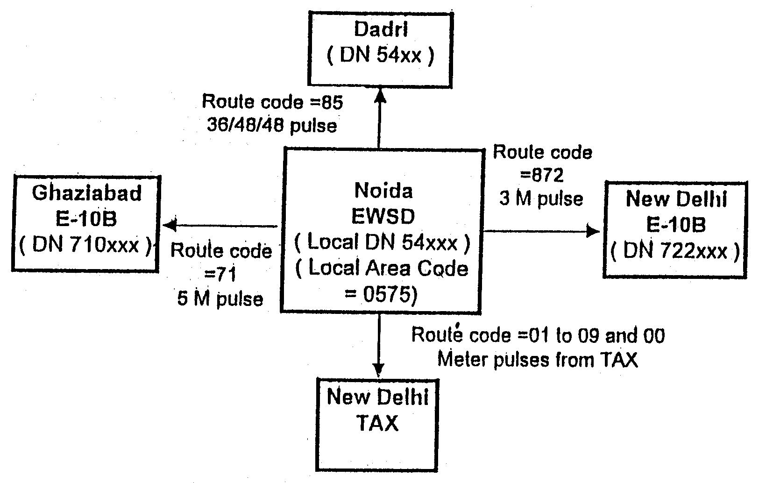
Fig. 3.1
Examples for creation of Zone points with MML commands

Figure 3.1 shows an example of NOIDA EWSD exchange connected to various other exchanges. We will now see the MML commands required for creation of zone points and associated details.
* Local Zone (54)
First the EWSD local zone point has to be created. This will be created in the following way :
CR ZOPT: LAC = 0575, ZONO = 22, CODE = 54, BILLING = METERING,
SUCHCN = CNTR2&CNTR4;
This command will create a zone point having zone number 22 for local calls. The billing will be normal metering with meter charges to be stored in the counter number 2 and 4. Now the tariff for this zone has to be created.
ENTR TAR: NAME = 5M, PLSCOM = 1-300000;
This command will create a tariff of one pulse every five minutes. This tariff will be linked with the zone using following command
ENTR TAR: NAME = 5M, ZONO = 22;
* Zone point for the code 71
Zone point and the associated tariff for the code 71 will be created with the same MML commands.
CR ZOPT: LAC = 0575, ZONO = 23, CODE = 71, BILLING = METERING,
SUCHCN = CNTR2&CNTR4;
ENTR TAR: NAME = 5M, ZONO = 23;
* Zone point for the code 872
We will use following commands for this zone.
CR ZOPT: LAC = 0575, ZONO = 24, CODE = 872, BILLING = METERING,
SUCHCN = CNTR2&CNTR4;
Since in this zone the 3 minute pulse is to be used the tariff will be created with the following commands.
ENTR TAR: NAME = 3M, PLSCOM = 1-180000;
ENTR TAR: NAME = 3M, ZONO = 24;
* Zone point for the code 01 to 09 and 00 (TAX calls)
For TAX calls the zone will be created in the following way. It is indicated in the Fig.2.0 that for the TAX calls the meter pulses will come from the TAX. This means that no tariff has to be created in the local exchange for the calls going to the TAX. This zone will have the zone number as 127, which means the zoning will be carried out in the higher ranking exchange (TAX). The MML command used will be.
CR ZOPT: LAC = 0575, ZOCHA = ZONINHI, CODE = 01,
BILLING = AMA&METRING, SUCHCN = CNTR2&CNTR4,
SUCACN = CNTR1;
The above command will create a zone for the call going to TAX with code 01. The zone point 127 is reserved for this zone and is not to be specified in the command. The parameter ZOCHA=ZONINHI will define that zoning will be carried out in the next higher exchange (in this case TAX). The BILLING parameter will have an additional value as AMA which will indicate that AMA records (detailed billing data) have to be generated for the calls to this zone. The counter value SUCACN = CNTR1 will specify, that the number of STD/ISD calls will be counted in the counter number 1.
Since the calls to the TAX will be starting with the number 01 to 09 (STD calls) or 00 (ISD calls) the command has to be given separately for the other codes, i.e. 02 to 09 and for 00. No command is needed to define tariff for this zone as the tariff is to be calculated in the TAX.
* Zone point for the code 85
For the code 85 the zone point will be created using following MML commands.
CR ZOPT: LAC = 0575, ZONO = 11, CODE = 85,
BILLING = AMA&METERING, SUCHCN = CNTR2&CNTR4;
For the tariff in this zone following commands will be used
ENTR TAR: NAME = 36S, PLSCOM = 1-36000;
ENTR TAR: NAME = 48S, PLSCOM = 1-48000;
In this case since two rates are to be used the tariff will be applied to the zone using the ENTR TARSW command in the following way.
ENTR TARSW: ZONO=11, NAME = 36S, TIME = 8-00, WDCAT = WO;
ENTR TARSW: ZONO=11, NAME = 48S, TIME = 8-00, WDCAT = HO;
ENTR TARSW: ZONO=11, NAME = 48S, TIME = 17-00, WDCAT = WO&HO;
Using the above three commands the tariff rate of the 36/48/48 will be created for the calls to the 85 zone.

EWSD
Familiarisation module for ITS Probationers
ROUTING ADMINISTRATION

PRESENTATION OBJECTIVES
The participant should be able to
- explain the basic components of routing
- appreciate the creation of a standard Outgoing connection
- appreciate the concepts of Announcement connections, Intercepts and Nailed–up connections in EWSD

What is inside ?
I Introduction
1. Definitions
2. Digit Translation

II Creation of a Standard Outgoing Connection
3. Trunk Groups and Trunks
4. Destination Areas and Routes
5. Code–points

III Announcement, Intercepts & NUCs
6. Announcement Groups and Lines
- Intercept codes
- Nailed–up Connectors

Self–check Quiz

Exercise

ROUTING ADMINISTRATION
1.0 Introduction (IN)
The Operation Manual OMN:EXCH–RO describes the tasks which are to be performed in an exchange to process outgoing and transit traffic. These tasks are divided into the following areas :
- Administration of Routing and Trunks
- Digit Translation
- Routing
- Intercept Codes
- Trunk Groups
- Announcement Trunk Groups
– Nailed–up connections
- Administration of CCS#7 (common channel signalling) network
1.1 Basic Definitions
The aim of routing is to find the correct PCM–Timeslot based on the dialling information of the A–subscriber.
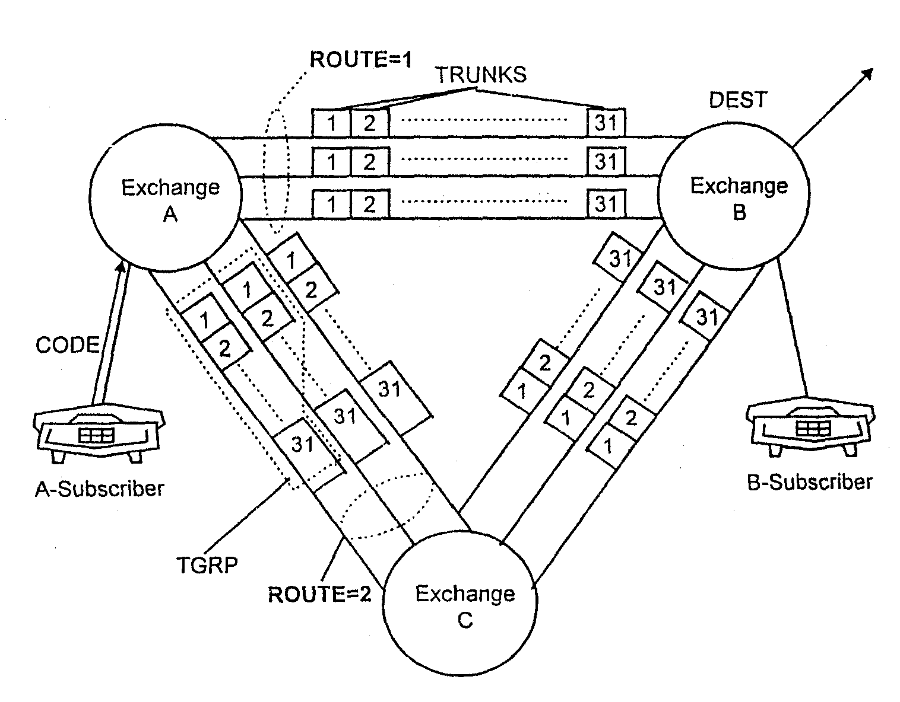
Fig. 1
Example : Call from Exchange A to Exchange B
The A–sub goes off hook and dials the digit information. Digit information means :
- if necessary, discrimination digit and country code.
- national area code.
- directory number of B–subscriber.
The digit information is evaluated in A–exch. The evaluation is done by the digit translator. The result is the destination area (in our example, Exch. B). This means that the digit information or CODE must be allocated to the destination exchange DEST.
The connection from A to B is possible directly or via exch. C. This means there are two ROUTEs to destination B. The routes will be seized in a defined sequence, i.e. Route–number. For example : Direct route may be assigned Route–number 1; Route via C may be assigned Route–number 2.
To connect the call, it is necessary to have a physical carrier, e.g. PCM. Time–slots of the PCM carrier can be used to reach the destination B. The timeslots are called TRUNKs.
All Trunks on the different PCM carriers to B can be grouped together under a trunk–group (TGRP). A TGRP is an administration unit.
- Digit Translation
Digit translation analyzes the dialling information and then determines how the call request is further processed. Before actual digit translation, which takes place in the CP, preliminary digit translation is performed on the A–side in the LTG.
2.1 Preliminary Digit Translation in the LTG
Preliminary digit translation in the LTG serves to reduce the number of messages which have to be exchanged between the LTG and the CP in order to set up a connection. Incoming dialled digits are first collected in the LTG and evaluated.
Preliminary digit translation tables in the LTG get automatically created when we define the code–points in the CP. It can, however, be specified with the command CR DIGIT GP also.
The number of translation steps required after the pre–translation depens on the digit chain in the digit translator.

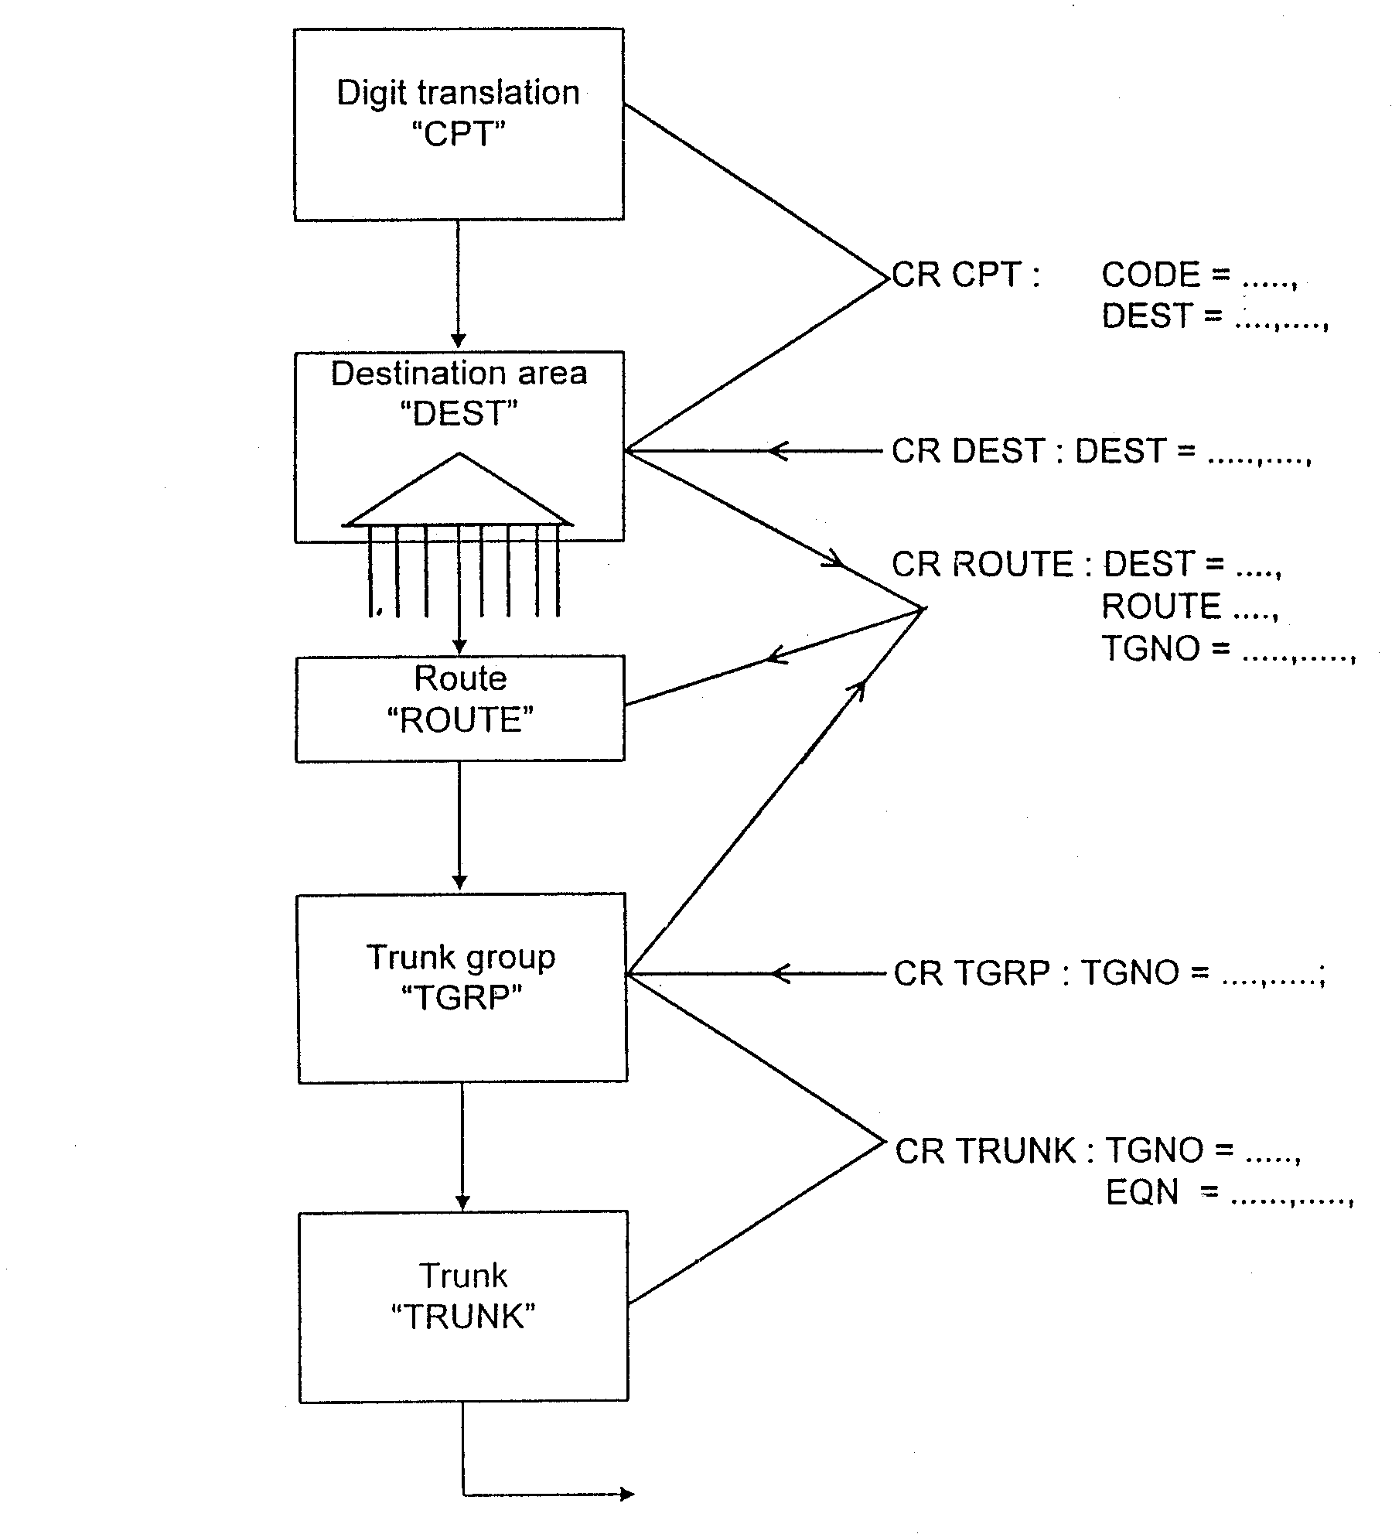

Fig. 2
Overview of Routing Definitions
Example :
Code–points in the CP : 01234
012356
0123578
Pre–translation in the GP : 0123
In the LTG, four digits are translated as standard. From the digit chain, it can be seen that up to three additional digits have to be collected, so that destination information can be provided in the CP without the need to request extra digits from the GP. For the code 0123578, the CP will send a COME AGAIN command to GP for each digit after 4th till the 7th digit.
  - Digit Translation in the CP
Digit translation in the CP for outgoing traffic and for traffic to intercept codes and announcements is performed with the aid of code points. In exchanges with two or more local networks, code point can be created for each local network. A code point assigns a destination to a digit combination. This destination can be :
- Destination area (DEST)
- Directory number block (DN)
- Intercept code (INCEPT)
Principle of Digit Translation
Fig.3 depicts the basic structure of the digit translator. The digit translator is composed of digit blocks. Each of these digit blocks contains a translation result for each hexadecimal digit (0 to F).
Translation result can be :
- Index to a further digit block.
- DESTination
- Index to a subscriber group table (Refer OMN : EXCH–SU)
- A service code (Refer OMN : EXCH–SU)
- Index to a special code
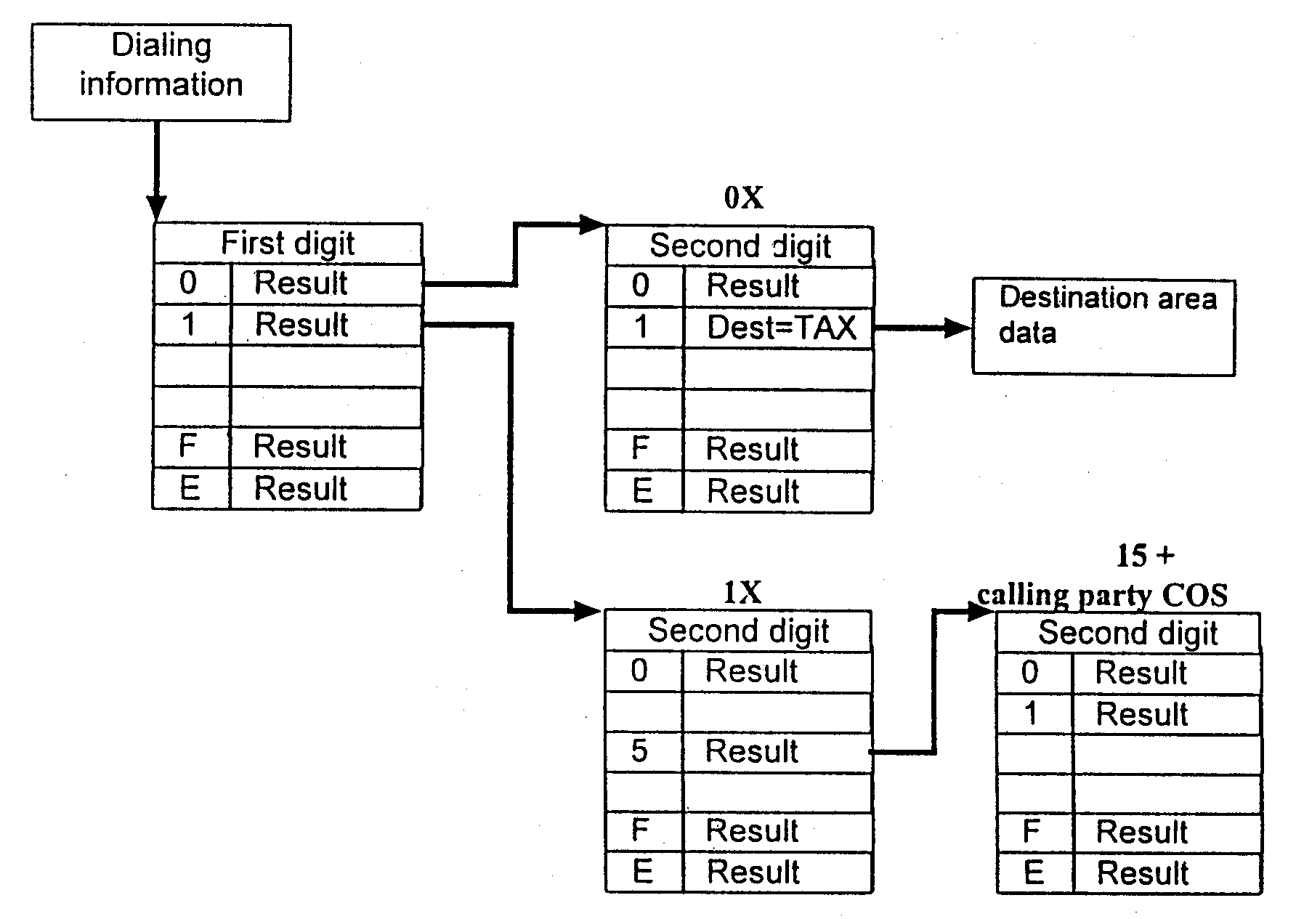
Fig. 3
Basic Structure of the DIGIT TRANSLATOR
( Chaining up to 16 digits )
II. Creation of a Standard Outgoing Connection
Steps in Data creation for O/G call :
- Creation of the O/G Trunk Group and Trunks (Section 3).
CR TGRP
CR TRUNK

- Creation of DESTination and its ROUTEs (Section 4).
CR DEST
CR ROUTE

- Creation of Code–point (CPT) and Zone–point (ZOPT) (Section 5).
CR CPT
CR ZOPT
  - Trunk Groups and Trunks
  - Trunk Groups
Trunk originating at the same distance exchange are compiled under one name as a trunk group. This makes it possible to access all these trunks under one name, the trunk group number, and to store data which apply to all the trunks under this name.
Trunk groups can be classified as follows :
- Incoming trunk groups | : | carry traffic towards the home exchange
- Outgoing trunk groups | : | for calls to other exchanges (An O/G trunk group is addressed via Code–point (CPT), Destination area (DEST) and the ROUTE. It can be reached via one or more ROUTEs).
- Bothway trunk groups | : | used for both directions, hence the data of outgoing and incoming trunk groups are necessary.
- Circuit groups | : | a trunk group which uses CCS7 signalling and whose circuits only transfer user information.

A trunk group can be created by the command :
CR TGRP
The following parameters can be administered for a trunk group.
TGNO | : | trunk group number (Mnemotechnic name to identify the Trunk Group, upto 8 characters).
OPMODE | : | operating mode (I/C, O/G or Bothway).
GCOS | : | class–of–service data, such as the dialling procedure (MFCR2 etc.).

For incoming trunks, following optional data can be specified in addition to the mandatory data specified above :
ORIG1 | : | originating mark 1 for routing (Based on the different ORIG1 values of the I/C Trunk groups, the same CPT can be routed to different destinations).
ORIG2 | : | originating mark 2 for zoning (Charging for the same route can be different depending on different ORIG2 value of the I/C TGRP).
PREFIX | : | prefix digits
LAC | : | local area code
STAT | : | statistics counter
GCOS | : | TRACL 1–15 Traffic Restriction Classes, similar to the SR values in E10B exchanges.  ETEX End–to–end control  SAT LINK Trunk Group linked to Satellite  SEND TAX Charging zone sent to parented exchange. The parented exchange will generate the meter pulses.  NO ZON Calls not zoned in the exchange.  DA R ALLOW Data request allowed. Calling party data can be requested.  SUB MFC Subs category requested via MFC.  L PRIO 0–6 Overload priority – In the event of an overload, only seizures of those trunks will be processed whose LPRIO is equal to or greater than the current overload level.
For circuit groups (i.e. TGRPs using CCS#7 signalling), an additional linkage is to be specified using command :
ENTR C7 TG REL :
TGNO | : | trunk group name
DPC, NETIND | : | code and network indicator of the destination point to which the circuit group leads
The CCS7 signals for this TGRP will be routed to the above–mentioned DPC (Destination Point Code) via the independent CCS7 network. The creation of the signalling links in the CCS7 network has been dealt in Training Objective 2.3.
There are dependencies between the above data. For example, the dialling procedure of the circuit group must be compatible with the user part which has been created for the destination point. A user part must be created for each destination point to which at least one circuit group leads.
Related Commands for Trunk Groups :
DISP TGRP | : | Displays TGRP data
MOD TGRP | : | Modifies TGRP data
CAN TGRP | : | Cancels TGRP  Prerequisite :  - The TGRP should not be linked to any ROUTE.  - The TGRP should not contain any trunk.
ENTR TG DAT | : | Modifies TGRP GCOS
CAN TG DAT
  - Trunks
A trunk assigns a port of an LTG to a trunk group. Data common to all trunks in a trunk group are generally stored as trunk group data. For certain trunk group types, however, a trunk dialing procedure can be entered which differs from the trunk group dialling procedure.
Trunks can be created by the command :
CR TRUNK :
The following parameters can be administered for a trunk :
TGNO | : | Trunk group number (8 characters)
LNO/CIC | : | Line number (1 to 4095) or  Circuit identification code (for CCS7 circuits) (0–1 to 511–31)  CIC must be identical in both exchanges and should therefore only be assigned after consultation with the distant exchange.
EQN | : | Equipment number (tsg–ltg–diu–ts)
LC OS | : | Class of service, such as circuit type or signalling system  DIGSIG3 Loop/MFC–R2 dec. type 3  DIGSIG4 Loop/MFC–R2 dec. type 2  DIGSIG5 Loop/MFC–R2 dec. type 1  DIGSIG7 ISUP (speech trunks) for CCS7  DIGSIG8 CCS7 signal trunk (nailed up to CCNC)  DIGSIG9 Alarm call
TSTTYP | : | Test data and test type (Refer MMN : TE)
Related Commands for Trunks :
DISP TRUNK | : | Displays Trunk data
STAT TRUNK | : | OST of trunk
SRCH TRUNK | : | For searching Trunks with a specified status
CAN TRUNK | : | Cancels Trunk (Prerequisite : The trunk must have been blocked condition using ENTR TR DAT)
ENTR TR DAT | : | To modify Trunk LCOS (e.g., to block a trunk)
CAN TR DAT | : | To cancel Trunk Blocking
  - Examples : Creation of Trunk Groups & Trunks
- Create an O/G Trunk Group to a DELHI AXE–10.
CR TGRP : TGNO = ODELHI, OPMODE = OG,
GCOS = MFCR2 & ETEX & ITITIMI & NONSEQ;
IDITIMI – Inter–digit time 1 (300/900 ms).
(The possible time–out values can be seen using DISP TI OUT)
NONSEQ – Random search (Line which is idel for the longest time is seized first).
- Create an I/C Trunk Group from Fetex – 150 Trg. Model exchange
CR TGRP : TGNO = IFET15, OPMODE = IC,
GCOS = MFCR2 & ETEX &
NOZON & SUBMFC & DARALLOW;

- Create Trunks in TGRP = OFET15;

CrTrunk : TGNO = OFET15, LNO = 1, EQN = 0–4–3–1,
LCOS = DIGSIG5 & MFCR2, BLK = NONE;
Create Trunks in TGRP = BWAKE for Morning Alarm service :

Cr Trunk : TGNO = BWAKE, LNO = 1, EQN = 0–2–6–1,
LCOS = DIGSIG9 & PULSDIAL, BLK = NONE;

Cr Trunk : TGNO = BWAKE, LNO = 2, EQN = 0–2–6–2,
LCOS = DIGSIG9 & PULSDIAL, BLK = NONE;

Cr Trunk : TGNO = BWAKE, LNO = 3, EQN = 0–2–6–3,
LCOS = DIGSIG9 & PULSDIAL, BLK = NONE;

Cr Trunk : TGNO = BWAKE, LNO = 4, EQN = 0–2–6–4,
LCOS = DIGSIG9 & PULSDIAL, BLK = NONE;

Cr Trunk : TGNO = BWAKE, LNO = 5, EQN = 0–2–6–5,
LCOS = DIGSIG9 & PULSDIAL, BLK = NONE;

Cr Trunk : TGNO = BWAKE, LNO = 6, EQN = 0–2–6–6,
LCOS = DIGSIG9 & PULSDIAL, BLK = NONE;

4.0 Destination Areas and Routes
4.1 Destination Areas
A destination area (DEST) is one of the possible results of analysis of the dialled digits. A DEST can be accessed via one or more code points.
There are several types of destination areas :
- Destination areas with Repeat Digit Translation.
- Destination areas with Standard Routing.
- Destination areas with Conditional Alternative Routing.
4.1.1 Destination Areas with Repeat Digit Translation
If a destination area of this type is addressed, the existing dialling information is replaced by a new digit combination with which digit translation is repeated. An example of the application of this type of destination area would be the origin–dependent routing of emergency calls. The standard emergency number (e.g. 100) is replaced by the number of the local police station.
CR DEST : DEST = Destination name

NEWCOD = New code with which the selected
code is replaced.
Example :
CR DEST : DEST = FRSmain, Newcod = 712198;
CR DEST : DEST = FRS–RSU, Newcod = 662198;
4.1.2 Destination Area with Standard Routing
Up to eight routes, via which a call can be set up, can be addressed via this type of destination area. The following data are stored under the destination area name :
CR DEST : DEST – Destination name

MINMAX – Minimum and maximum number of digits of
the directory numbers of the destination area
TLIM – Various time limits :
Dial time supervision
Call time supervision
Release time for A– and B–sides
Call time limit

TRAT – Traffic type for destination–specific traffic
restriction
e.g., Local, NAT1–4,
INTNAT, Default = NOBLOCK
4.1.3 Destination Areas with Conditional Alternative Routing
Destination areas with conditional alternative routing are used to distribute traffic to different carriers serving particular areas. Destinations for carrier selection are initially created as Standard Destinations (Sec. 4.1.2) and then modified using ENTR DEST DATA.
4.1.4 Destination–specific Traffic Restriction
Destination–specific traffic restriction makes it possible to limit the traffic of certain destination areas to a specified number of seizures.
4.2 Routes
A route of a destination area leads to a trunk group, via which the requested call can be set up. The routes of a destination area are searched for an idle trunk in the sequence of their route numbers. If no idle trunk is found even in the last route of the destination area, the call is rerouted to an intercept code by the call processing programs.
The following data can be entered for a route :
CR ROUTE
DEST | – | Destination area to which the route belongs.
ROUTE | – | Route number, i.e., one of the 8 positions of the route in the seizure attempt sequence.
TGNO | – | Trunk Group number of the trunk group referenced by the route.
SSDI | – | Start Sending Digits, i.e. the digit position from which the digits will be sent on the trunk.
DICON | – | Data for digit conversion (for CCS7 routes DICON is to be specified in place of SSDI).
EOS | – | the way how the End–of–Selection is defined, e.g.  EOS = SIGN implies EOS signalled by backward signal.  EOS = PROG implies EOS determined by time–out condition.

Try in the lab :
DISP ROUTE | : | Displays Route data for a DEST
MOD ROUTE | : | To modify desired parameters of a Route
CAN ROUTE | : | Cancels last Route.
INS ROUTE | : | Inserts a Route anywhere in the hunting sequence.
TAKOROUTE | : | Cancellation of any route (anywhere in the hunting sequence of the DEST)
ACT ROUTE | : | Activates a barred Route.
BAR ROUTE | : | Bars a Route in the hunting sequence of a DEST.

- Code–points
A code–point is created to define a destination for the specified digit–combination.
CR CPT : CODE : Digit combination (up to 15 digits).
DEST : Destination Area
Code–point based on the calling party Class of Service :
To perform digit translation dependent on the origin and the type of call, the same digit code can contain different destinations for the following special codes :
– ORIG1 | Originating mark 1. ORIG1 is a subscriber or incoming Trunk feature. It can be assigned to a subscriber or trunks from a certain geographical area and makes it possible to assign different Destinations depending on the call–originating area.
– MFCAT | MFC category  = SUB ORD for calls from ordinary subscribers.  = SUBPRIOR for calls from priority subscribers.  = TESTEQ for calls from Test Equipment.  = COINB for calls from Coinbox Telephones.  = OPOS for call from Operator Positions.  = DATATRANS for Data transmission calls.  This category can be sent over a trunk with the help of an MFCforward signal.
– ROUTYP | Route type for ISDN traffic  = ROUTYPE0 : Analog signalling preferred.  = ROUTYPE2 : ISDN user part (ISUP) trunks preferred  = ROUTYPE4 : for call from ISDN subs, which can’t be handled by analog network. The corresponding DEST may therefore only contain ISDN routes.  By means of ROUTYP, the traffic is distributed to the appropriate transmission paths. This ensures that ISDN traffic uses transmission paths with which the relevant ISDN features can be implemented.
– LAC | Local Area Code
– ZDIG | Language digit

The special codes, which are analyzed in addition to the dialled digits, are derived from calling party class–of–service data.
Related Commands : (with sample parameters)
DISP CPT : code = x;
MOD CPT : code = 31,
CAN CPT : code = 33, incept = UNOBDE0;
  - Example : Creation of Destination, Route & Code–points
- Create a destination in a Ghaziabad exchange for level ‘8’ calls to a DELHI Local–cum–TAX exchange.
CR DEST : DEST = Delhi,
TRAT = Local,
MINMAX = 5–7;

Create another destination for routing STD calls via the same Exchange
CR DEST : DEST = TAX,
TRAT = nat0,
MINMAX = 6–11;

- Create one route each in both the destinations using the TGNO created in Sec 3.2.

CR ROUTE : DEST = DELHI, DEST = TAX,
ROUTE = 1, ROUTE = 1,
TGNO = ODELHI, TGNO = ODELHI,
SSDI = 2, SSDI = 1,
DINO = D5, DINO = D6,
EOS = SIGN; EOS = SIGN;

Note that though the same TGRP has been used in both the destinations, still the SSDI (Rank of Digit) for level ‘8’ calls is 2, whereas SSDI for TAX calls is ‘1’.

- Create a code–point for calls from Analog subscribers to the above exchange (Code 833) :

CR CPT : CODE = 833, CODE = 01
DEST = Delhi, DEST = TAX
ROUTYP = ROUTYP0; ROUTYP = ROUTYP0;
ROUTYP2; ROUTYP2;

Create a code–point for ISDN calls to the same codes :

CR CPT : CODE = 833, CODE = 01
DEST = Delhi, DEST = TAX
ROUTYP = ROUTYP4; ROUTYP = ROUTYP4;

  - Several Local Networks at One Exchange
Up to 15 different local networks can be connected to one exchange. The directory number volume can be present once (unique) or more than once (multiple) (see OMN:EXCH–SU). It is possible to administrate parts of one or more local networks from the home exchange, while the other parts (of these local networks) are connected to a distant exchange (See Fig. 5).
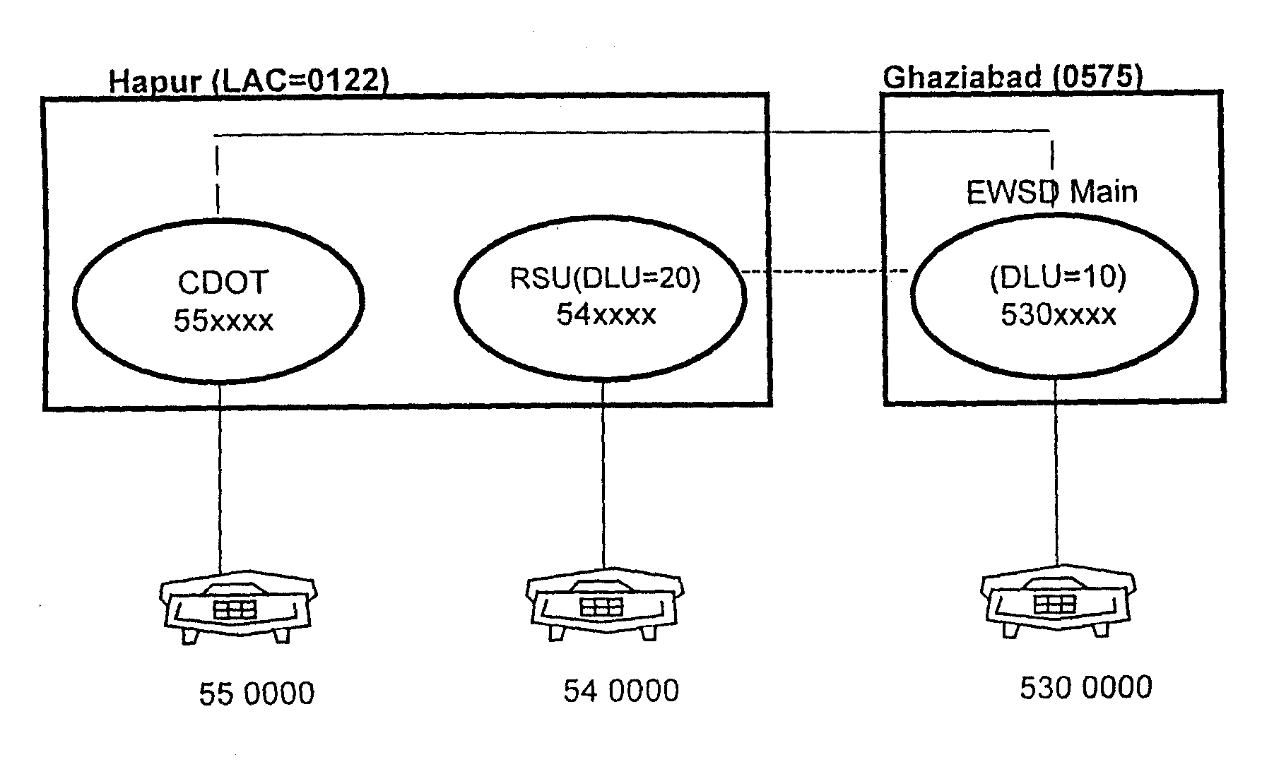
Fig. 4
Part of Second Local Network connected as RSU to the EWSD Main Exchange
To enable local area codes to be recognized in exchanges with multiple directory number volume, the initial results of the digit–destination translator is used for a logical comparison of the dialled digits with the digits of the local area code.
Zoning, of course, must be defined separately for individual local networks.
III Announcements, Intercepts and NUCs
Announcement Groups
Announcement lines leading to the same announcement are compiled under one name as an announcement group. This makes it possible to access all lines under one name (the announcement group number), and to store data common to the lines under this name.
Announcement group can be created by command
CR ANGRP : TGNO = trunk group number

GCOS = CHARGABLE (charge treatment)

= OCANEQ (Operator controlled
individual Announcement Equipment)
Announcement groups are accessed the same way as trunk groups, i.e. via ‘Destination area’ and ‘Route’. For individual announcements and for standard announcements which cannot be dialled, the destination area is addressed via intercept codes with repeat digit translation or new destination area.
Related Commands :
DISP ANGRP
CAN ANGRP The Group must be ADMIN BLOCKed first.
ENTR ANGCOS : To enter Ann. Group COS
CAN ANGCOS : Cancels Ann. Group COS
  - Announcement Lines
An announcement line assigns a part of an LTG to an announcement group. This port must be fitted with recorded announcement equipment. This LTG port should be created as,
CR LTU : LTG = x–y, LTG = z, Type = D30, Applic = CASRCA;
An announcement line can be created by command
CR ANLN ; TGNO – Trunk group number

LNO – Line number

EQN – Equipment number (tsg–ltg–ltu–port)

SEIZMX – Specifies how many subscribers can listen to an announcement simultaneously (broadcasting). For individual announcements, the maximum value must always be 1.

LCOS – Line classes of service, such as circuit type or signalling system.

Related Commands :
DISP ANLN :
STAT ANLN :
SRCH ANLN :
CAN ANLN : Prerequisite : The ann. Line should have been ADMIN BLOCKed using ENTR ANLCOS.

DISP LIST TO AN : Display listeners to announcement

ENTR ANLCOS : Enters Ann. Line COS (Line blocking, modification of SEIZMX).

CAN ANLCOS : Cancels Ann. Line COS
  - Example : Creation of semi–permanent data for Announcement Group No. 11
- Creation of LTU (if required).
CR LTU : LTG = 0–4, LTU = 0, Type = D30, Applic = CASRCA;

- Create the Trunk Group no. 11 and the Announcement Line no. 1 :
CR AN GRP : TGNO = ADAS11,
NUMCYC = 2;

CR AN LN : TGNO = ADAS11,
LNO = 1,
EQN = 0–4–0–11,
SEIZMX = 16;
(Note that it is possible to have

- same announcement on more than one Time–slot. The additional Time–slots will be added to the same TGRP using LNO = 2,3 and so on.

- more than one DAS).

(iii) CR DEST : DEST = DAS11,
MINMAX = 3–3,
TLIM = ONCALL;

(iv) CR ROUTE : DEST = DAS11,
ROUTE = 1,
TGNO = ADAS11,
EOS = PROG;

(v) Create the Code point (say ‘A11’) for accessing the ANGRP

CR CPT : CODE = A11,
DEST = DAS11;
(This CPT can be used by other exchanges which do not have their own Announcement system).

(vi) CR ZOPT : CODE = A,
LAC = 0575,
ZOCHA = NOPULSE;

- Intercept Codes
An intercept code indicates how a call request should be further handled if call processing addresses the intercept code. An intercept code is addressed if :
- the call cannot be set up as requested (e.g., no idle trunks or blocked subscriber).
- special resources are needed to set up the call (e.g., looping in echo suppressers from an echo suppresser pool).
- acknowledgement tones are to be sent to the A–side to signal whether subscriber–controlled input was correct or not.
The command for creating the Intercept code is
CR INC :
The actions which result from addressing an intercept code can be specified by the operating personnel in the form of ‘Intercept Result’. Options are as follows :

* INRES = TONE apply tone

* INRES = NEWCOD repeat addressing of digit translator with a new digit combination.

* INRES = NEWDEST addressing of a new destination area

* INRES = IGNORE continue call setup even though intercept code has been addressed.

If intercept codes which have not been created by the operating personnel are addressed by call processing, a tone is applied. The type of tone is defined in the GP and is dependent on the type of intercept code.
8.0 Nailed–up Connections
Nailed–up connection are permanent connections through the switching network between A–side and B–side. The ports involved in a nailed–up connection must be created and equipped.
Depending on type of use, nailed–up connections are classified as :
- NUC between any two numbers.
- NUC for access to packet switching networks.
9. Self–check Quiz Max. marks : 30
1. Preliminary digit translation is done in …………. 1
2. The purpose of preliminary digit translation is 1
3. The extent of depth of Preliminary digit translation for a code 033 will normally be ……. digits. 1
4. ORIG1 & ORIG2 can be defined for 1
- I/C Trunk Groups
- O/G Trunk Groups
- B/W Trunk Groups
- They are not defined for Trunk Groups
5. Which of the following line signalling should be used for Digital Media between two new–tech exchanges ? 1
- MFCR2
- pulsdial
- digsig5

6. The above signalling can be defined for 1

- The full TGRP
- Individual Trunks
- Either way

7. How is the EQN defined for a trunk ? 1
…….…–……….–……….–……….

8. The calls to 100 are to be diverted to 540000. How it can be done ? 1

9. To cancel a trunk, the trunk should first be blocked using 1
- ENTR TR COS
- MOD TRUNK
- CONF TRUNK
- ENTR TR DAT

10. The command for creation of an Announcement TGNO is 1

- Can you create a code–point to directly listen to an announcement by
dialling this code ? 1

- If the Track no. 5 in the DAS has gone faulty, can it be replaced with some other track ? 1

13. What will happen if you do not create INTERCEPTs in an EWSD ? 1

14. Can you create an intercept ‘NAMASKAR’ and route it to a greetings 1
announcement ? If yes, how ? If no, why not ?

15. ORIG1 is used for ……………………………. and 2
ORIG2 is used for …………………………….

- In the case of an outgoing call the digit translator leads to …………., which in turn will lead to a ………….. This ………. gives access to a ………….. wherein ultimately a free …………. will be searched for .
(DEST, TGNO, ROUTE, TRUNK)
3

- The sequence for creation of a standard outgoing connection is

- CR CPT
- CR ZOPT
- CR DEST
- CR ROUTE
- CR TGRP
- CR TRUNK

- The SSDI stands for ………… …………. …………..

In the common parlance this is also known as ………… .. ………… . …………
In case of a call from Ghaziabad Local to Madurai (code 0452) via Delhi TAX and Madras TAX, what should be the SSDI value at

Ghaziabad
New Delhi TAX
Madras TAX
Madurai TAX
Madurai Local 2

- What does the parameter INRES for CRINC mean ? Write one possible value of this parameter. 2

- You dial a busy subscriber and receive an announcement ? ‘All the routes dialled are busy’. How will you check the error in exchange data ? How do you rectify the error ? 2

- You have dialled a number 540200 which is unobtainable. But you get an announcement greeting to you for the Happy New Year ?

On trying DISP INC : INCEPT = UNOBDN; you find the correct reference to the announcement (i.e., as per the standard announcements list). What next ? 4
Lab Exercise
- Create a trunk group ODELHI with Trunks from Ghaziabad (EWSD Trg. Model Exchange) to New Delhi (AXE–10 Trg. Model) using LTG 0–4, DIU no. 2. Use MF register signalling as MFC R2 and line signalling as Digital Signalling of type 1.
- Use this Trunk Group to route all level 81 calls meant for all Delhi exchanges. Digit 81 are not to be sent. Dial 81–3100128, 81–7110000 etc. and verify. use DEST = DELHI.
ODELHI
OTAX

- Create another trunk group OTAX from Ghaziabad EWSD to Delhi TAX (Fetex – 150 Trg Model) using LTG 0–4, DIU 3 with same parameters as above.

- Use this TGNO to route all STD & ISD calls. Use DEST = TAX.
[Create DEST, Route, CPT).

- Create data to use OTAX as an alternate route for level–8 calls.
Block the trunks on ODELHI using ENTR TR DATA. Dial 8–3100128 to verify the routing.
[Hint : Do you need to create another DEST ?].

- Create exchange data in Ghaziabad EWSD for receiving calls from Delhi local subscribers (AXE–10 subscribers). Use TS–21 of the PCM used in (a) above. Dial 8–540000 and verify.
[Also work out how this call is being routed].

